COPYRIGHT TRANSFER AGREEMENT

Title of the manuscript: Penggunaan Kalkulating (Kalkulator Deteksi Stunting) Untuk Peningkatan Parental Feeding Style
The authors hereby transfer copyrights in and to the manuscript named above in all forms and media, now or hereafter known, to Jurnal Kesehatan Poltekkes Kemenkes RI Pangkalpinang effective if and when the paper is accepted for publication.

Everyone who is listed as an author in this manuscript should have made a substantial, direct, intellectual contribution to the work and should take public responsibility for it.

This manuscript contains works that have not previously published or not under consideration for publication by another journals.

Sincerely,
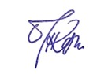
Corresponding author: _______________________ _______________ _______________
Ratna Suminar 25 Desember 2024

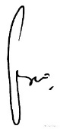
Authors: ____________________________ __________________ __________________
Ririn Lestari 25 Desember 2024

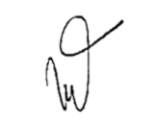
____________________________ __________________ __________________
Widya Maya Ningrum 25 Desember 2024

____________________________ __________________ __________________
Silvia Widyani Heriyanti 25 Desember 2024

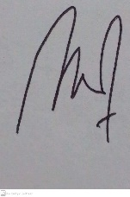
____________________________ __________________ __________________
Henri Setiawan 25 Desember 2024

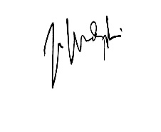
____________________________ __________________ __________________
Fatmawati Karim 25 Desember 2024
* This form must be signed by all authors in order as appeared in the manuscript.

